Recognising Early Soft Signs, Take Observations,
Respond and Escalate (RESTORE2 mini)
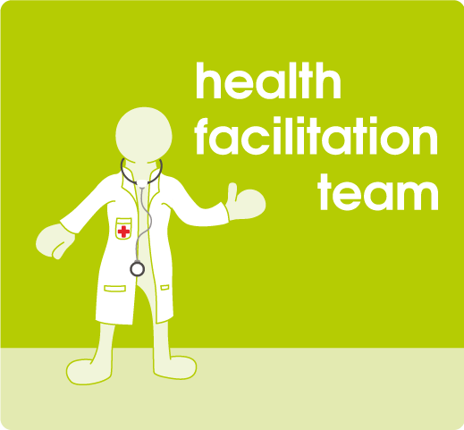

The training scheme aims to introduce the use of pulse oximetry and the RESTORE2 mini tool into care settings for people with learning disability in Leeds, to improve outcomes for this population by ensuring the right interventions are made at the right time.
The Learning Disability Health Facilitation Team is delivering a training session via Zoom on the date below.
Please contact Natasha Bradburn (team secretary) on getcheckedout.lypft@nhs.net to book places, receive the resources and arrange allocation of pulse oximeters.
Tuesday 17th January 2023
13:00-14:00

Tuesday 21st February 2023
13:00-14:00

Tuesday 21st March 2023
11:00-12:00

Tuesday 18th April 2023
13:00-14:00

