Recognising Early Soft Signs, Take Observations,
Respond and Escalate (RESTORE2 mini)
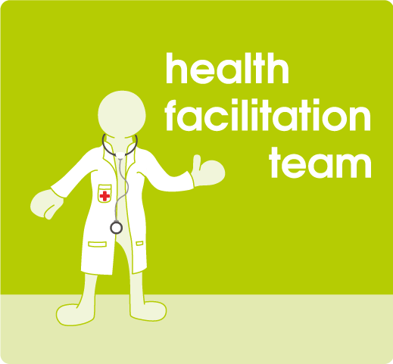

The training scheme aims to introduce the use of pulse oximetry and the RESTORE2 mini tool into care settings for people with learning disability in Leeds, to improve outcomes for this population by ensuring the right interventions are made at the right time.

The Learning Disability Health Facilitation Team is delivering a training session via Zoom on the date below.

Please contact Natasha Bradburn (team secretary) on getcheckedout.lypft@nhs.net to book places, receive the resources and arrange allocation of pulse oximeters.

Tuesday 27th September 2022
13:00-14:00

Tuesday 18th October 2022
13:00-14:00

Monday 14th November 2022
13:00-14:00

Thursday 8th December 2022
13:00-14:00

