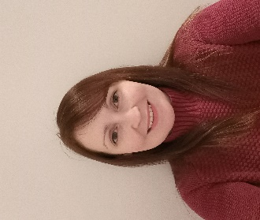

Hello my name is Anne-Marie
I am a learning disability nurse (RNLD).
I work in the Health Facilitation Team within Leeds and York Partnership NHS Foundation Trust (LYPFT).
The Health Facilitation Team are a team of health professionals who work strategically with other professionals. We also create easy read and accessible information for people with a learning disability.
We offer support to practices about how to care for people with a learning disability.
We have a website with all our accessible resources on www.learningdisabilityservice-leeds.nhs.uk/get-checked-out/
We offer training sessions, consultations, advice and support regarding learning disabilities and annual health checks.
We can review and validate learning disability registers to ensure they are accurate.
I am the link nurse for the following PCN’s York Road, Wetherby, Seacroft, LS25/26, Crossgates, Chapeltown, Central North Leeds, Burmantofts, Harehills and Richmond Hill
Please get in touch by emailing anne-marie.barrell1@nhs.net or getcheckedout.lypft@nhs.net

