 | This document will advise clinicians how to support a person with a learning disability who is needle phobic and therefore refuses their flu vaccination.
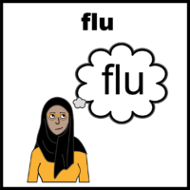 | People with a learning disability are an eligible cohort in the flu vaccination programme as they are more at risk of early mortality.
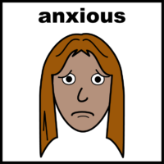 | People with a learning disability may experience more anxiety relating to having an injection.  You are entitled to, for those who are needle phobic to consider administering the nasal spray.
You are able to administer the nasal spray flu vaccination to under 18s using the PGD. For over 18’s it can be administered ‘off-Label’ using a PSD.
Flu vaccination programme: information for healthcare practitioners p.49.
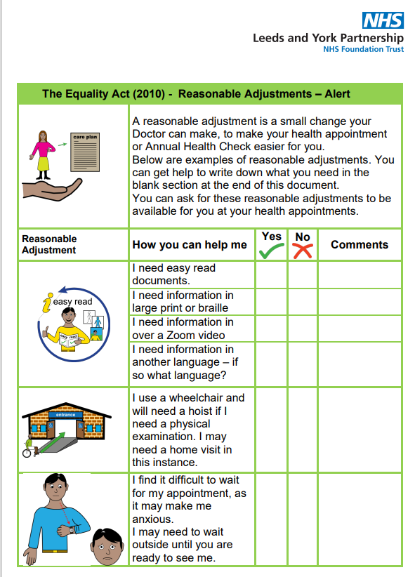 | Remember you have a legal obligation to offer a reasonable adjustment to support a person with a learning disability. This support should help them to access health care opportunities.  Flu Vaccinations: supporting people with LD

