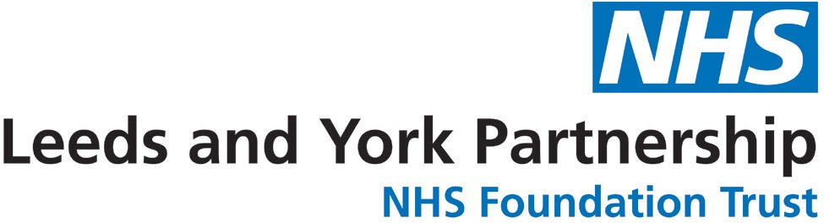

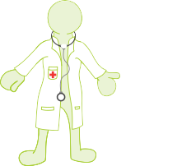
Leeds RESTORE2mini and Pulse Oximetry Pilot Scheme.

This pilot scheme aims to introduce the use of pulse oximetry and the RESTORE2 mini tool into care settings for people with learning disability in Leeds, to improve outcomes for this population by ensuring the right interventions are made at the right time.

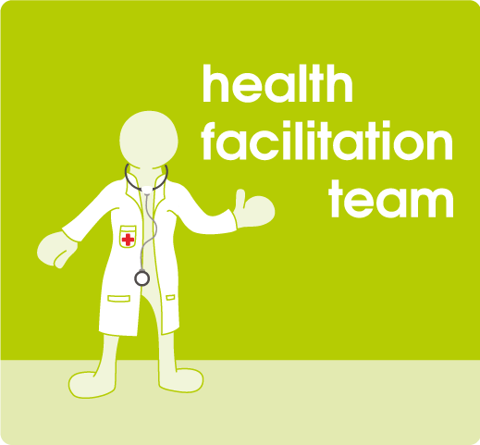
The Learning Disability Health Facilitation Team are delivering training sessions via Zoom on the dates below. Dates may change depending on demand and group size.

Please contact Natasha Bradburn (team secretary) on getcheckedout.lypft@nhs.net to book places, receive the resources and arrange allocation of pulse oximeters.

January

Wednesday 12th 1 – 2.30pm
Wednesday 26th 1 – 2.30pm

