The Equality Act (2010) - Reasonable Adjustments – Care Plan
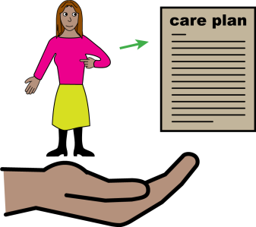 | A reasonable adjustment is a small change your Doctor can make, to make your health appointment or Annual Health Check easier for you.  Below are examples of reasonable adjustments. You can get help to write down what you need in the blank section at the end of this document.  You can ask for these reasonable adjustments to be available for you at your health appointments.
Reasonable Adjustment | How you can help me | Yes | No | Comments
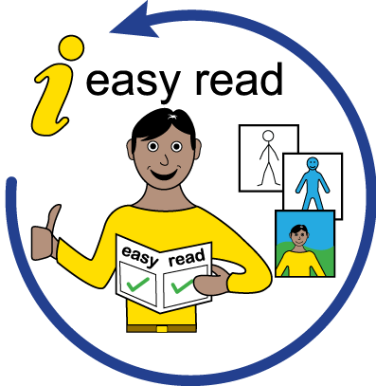 | I need easy read documents.
 | I need information in Braille
 | I need information in large print.
 | I need information in another language – if so what language?
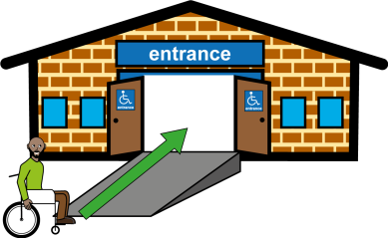 | I use a wheelchair and will need a hoist if I need a physical examination. I may need a home visit in this instance.
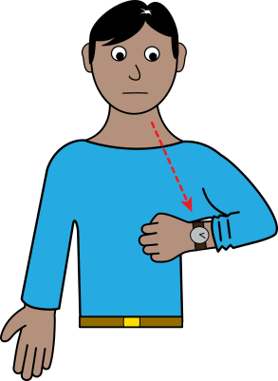 | I find it difficult to wait for my appointment, as it may make me anxious.  I may need to wait outside until you are ready to see me.

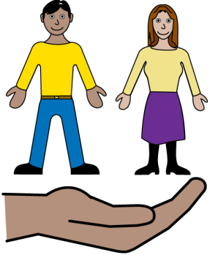 | I get very nervous at appointments and need my carer to help me understand what is happening.
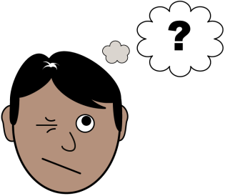 | I may need to visit the surgery before my appointment to feel comfortable in the environment.
 | I need a longer appointment.
 | I need time to process information and answer questions.
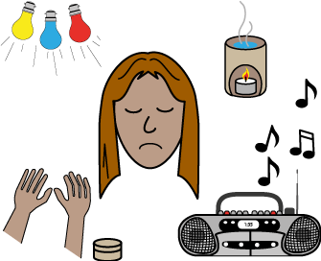 | Bright lights or loud noises may affect me.
 | My carer will support you to understand my needs.
Other reasonable adjustments?
Name: Date of birth:
Health Organisation – please log these reasonable adjustments on your alert system

